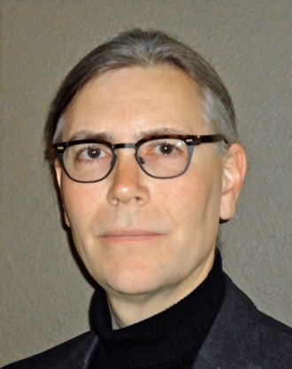Professor James P.M. Syvitski received his doctorate from the U. of British Columbia in 1978, where he developed a quantitative understanding of particle dynamics across the land-sea boundary. He has held a variety of appointments within Canadian universities (1978-95) and was a Senior Research Scientist within the Geological Survey of Canada and the Bedford Institute of Oceanography (1981-95). James served as Director of INSTAAR – a CU Earth and Environmental Systems Institute from 1995-2007, and presently holds faculty appointments in various departments (Geological Sciences, Applied Mathematics, Atmosphere & Ocean Sciences, Hydrological Sciences, and Geophysics). Professor Syvitski is presently Executive Director of CSDMS— Community Surface Dynamics Modeling System, an international effort to develop, support, and disseminate integrated software modules to the broader Geoscience community. James also Chair’s the International Geosphere-Biosphere Programme (IGBP) that provides essential scientific leadership and knowledge of the Earth system to help guide society onto a sustainable pathway during rapid global change. Professor Syvitski received the 2009 Royal Society of Canada, Huntsman Medal for Outstanding Achievements in Marine Science, and is a Fellow of the American Geophysical Union.