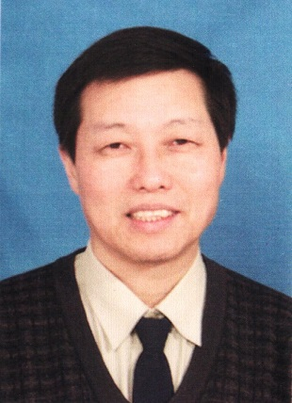Professor Chuijie WU graduated at Jiangsu University on Jan. 1982, and as a visiting scholar, senior visiting scholar and visiting professor, he worked at Department of Mechanical and Energy Engineering, Cardiff college of Wales University, UK, from 1986 to 1987; University of Tennessee Space Institute, from 1988 to 1989.; Department of Mechanical Engineering, Johns Hopkins University in 2000; Department of Mathematics, Kennesaw State University, USA in 2012.

He was directly promoted from Lecture to Professor on Dec. 1992 at PLA University of Science and Technology. He was Professor of Department of Mechanics, Peking University from 1999 to 2003. He was the one of ten Chair professors at PLA University of Science and Technology from Dec, 2003 to Jan, 2008. As the Founding Dean, he found the School of Aeronautics and Astronautics, Dalian University of Technology on Dec. 2008, and worked till now.

He holds following academic positions:

Executive Member of Council of Chinese Association for Computational Mechanics; Member of International Committee of Asian Computational Fluid Dynamics Conference; Invited Member of Working Party of Computational Mechanics of Chinese Society of Theoretical and Applied Mechanics; Member of Liaison Committee of Southern Computational Mechanics; Member of Consultative Committee of State Key Laboratory of Scientific and Engineering Computing, Chinese Academy of Sciences;   
 Associate Editor of Advances in Applied Mathematics and Mechanics (AAMM); Associate Editor of Science China-Phys Mech Astron.

Referee of about 20 academic journals, such as Journal of Fluid Mechanics, Journal of Computational Physics etc.   
 His research fields include:

(1). Aerodynamics, vortex dynamics and flow control

(2). Turbulence and nonlinear dynamics  
 (3). Computational fluid dynamics

(4). Environment fluid mechanics

Published about 230 papers in above fields.